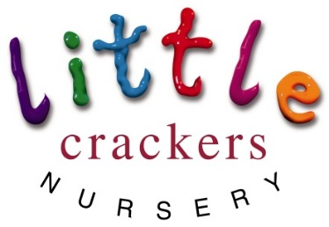
Weekly News

17th May 2019
Nursery notices:  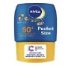  Summer protocol:  Please put 24hr suncream on your child before nursery.  We will top up the suncream in the afternoon if necessary, if you have left us a named ‘bottle’.  Please leave a named hat with us – they live in the hat box which makes it easier to get everyone outside quickly!  Early mornings can still be a little chilly, even on a warm day, and the sun can still be strong later in the afternoon: with this in mind please make sure your child has a light cardigan or jumper for easy coverups.  Thank you x  Due to this term being so short we will not be sending the photo observations at half term.  All the pre-school children will receive a full written report, and everyone else will receive the photo observations as usual, at the end of the summer term. |  | Dates to remember:  Half term (term time children)  Mon 27th May-Mon 3rd June  SPORTS DAY!!!  Thursday 13th June 9.30am  PRE-SCHOOL GRADUATION!!!  Tuesday 25th June (afternoon)  School closes for the Summer  (term time children)  Wednesday 3rd July
Joke of the week:  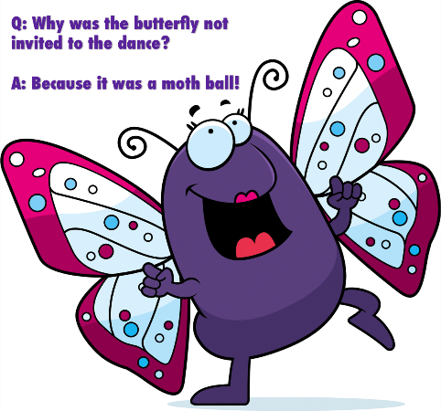 | Caterpillar Watch…  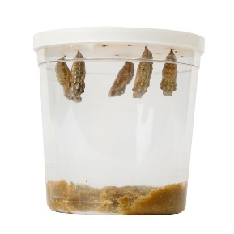  We have 5 cosy cocoons hanging!! |  | Registration Forms  Please return any outstanding forms to Mrs Bird as soon as possible  Thank you x
Little Crackers Nursery · Crackley Hall · St Joseph’s Park · Kenilworth · CV8 2FT
Telephone: 01926 514444 · Fax: 01926 514455 · e-mail: littlecrackers@crackleyhall.co.uk
www.crackleyhall.co.uk

Registered Charity Number 1087124 Company limited by guarantee Number 4177718

You can email Mrs Bird clarebird@crackleyhall.co.uk
or ring the nursery direct 01926 514456

